
NEW

Photo Books
+
Calendars
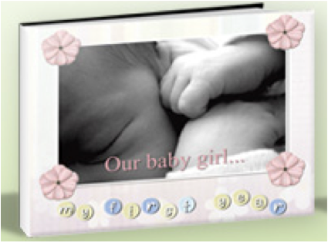
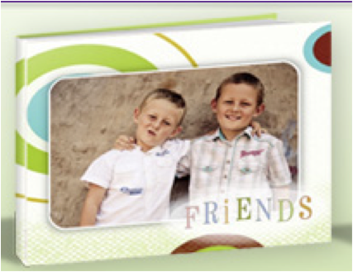
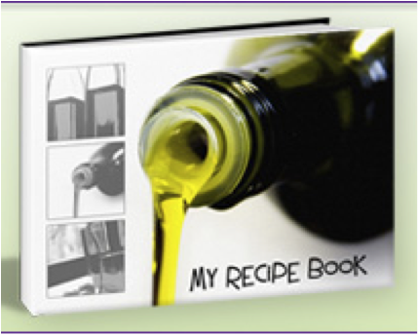


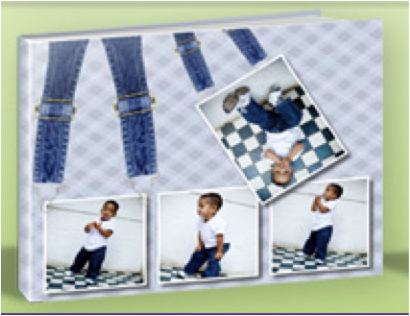
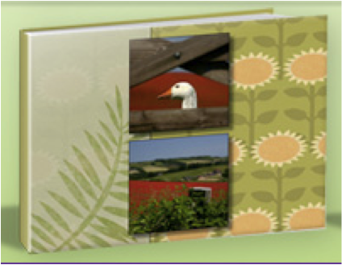

You provide us with the photos and we do all the work.
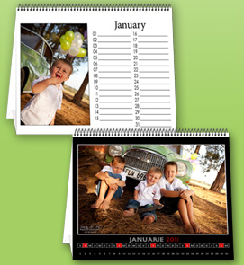
Flip Desktop Calendar
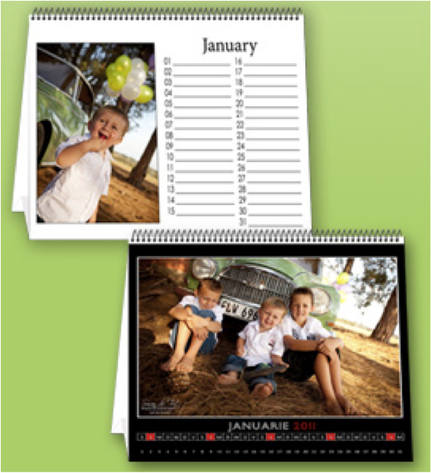

Size: 200mm x 250mm
Printed on 200 gram Satin paper
Frosted sheet Front
Triangle Board
Wire Bound

Price: R219
Photo Books
A5 Landscape
195mm x 145mm
20 Pages

Extra 2 page print – R14
A5 Printed Hard Cover
R371
A5 Crushed Leather Hard Cover
R350
A5 Printed Soft Cover
R252

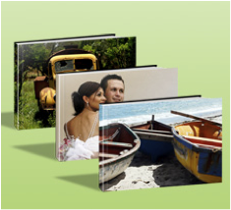
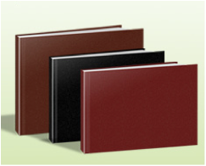
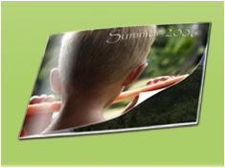

A4 Printed Hard Cover
R665
A4 Printed Soft Cover
R462
A4 Crushed Leather Hard Cover
R636

Extra 2 Page Print – R23

A4 Landscape
280mm x 210mm
20 Pages
Photo Books
A4 Portrait
210mm x 270mm
20 Pages

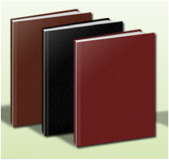
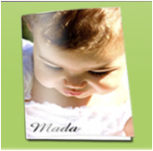
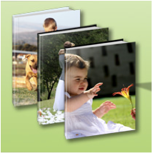
A4 Crushed Leather Hard Cover
R597
A4 Printed Hard Cover
R607

A4 Printed Soft Cover
R457

Extra 2 Page Print – R23

Photo Books
A3 Landscape
370mm x 285mm
20 Pages
A3 Printed Hard Cover
R1091

A3 Crushed Leather Hard Cover
R1049

Extra 2 Page Print – R39

Photo Books
Square
300mm x 300mm
20 Pages
Square Crushed Leather Cover
R915
Square Printed Hard Cover
R933

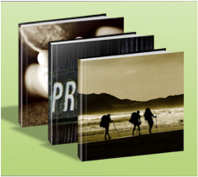
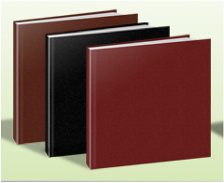

Extra 2 Page Print – R39

FOILING: R62 on Leather Covers
Designing your album: 2-3 weeks
Designing your Calendar: 1 week (or less)
Printing: 1 week
Designing on all orders only starts once 50% deposit is paid.
The remaining 50% is required once book arrives.

Soft Cover books no more than 30 pages and not available for 300mm x 300mm square or A3.

If you want photos to be in a specific order, please number the photos clearly.
For all Calendars please number photos clearly or name them according to months.

Foiling is only for Leather Covers: Name, Surname & Date only. Standard font and Size. Right Hand side Corner.

Please complete the order form before we can start on your order.

Contact Persons:
Shantelle: choice.designs@yahoo.com (0826887912)
Roxzanne: roxzanne.fortoen@gmail.com (0718728404)

